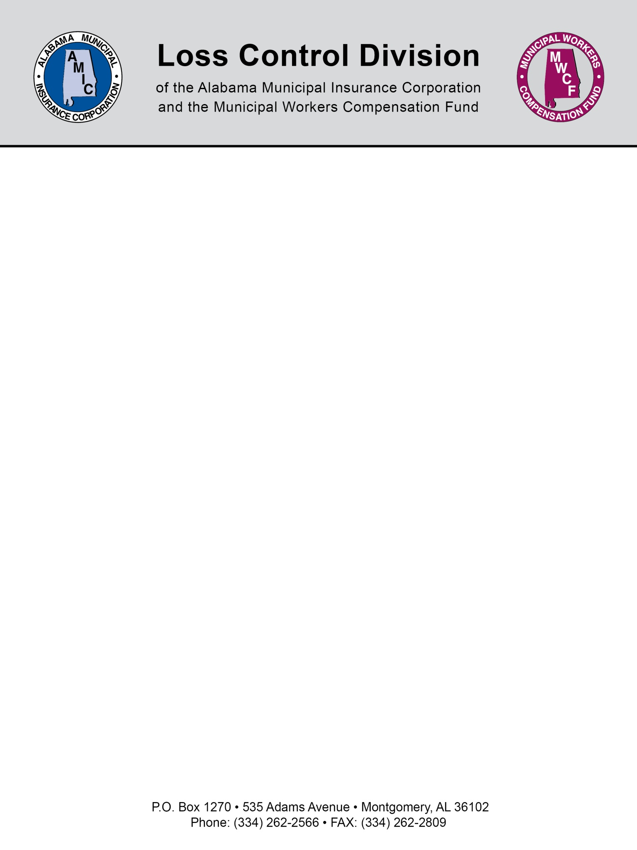

Bleacher Safety Guidelines

In response to injuries and deaths from falls from bleachers, the U.S. Consumer Product Safety Commission has issued “Guidelines for Retrofitting Bleachers”. Several states have adopted legislation which requires bleachers to conform to guidelines set out under uniform building codes and the 2000 National Fire Protection Association (NFPA 101) Life Safety Code.

To promote greater safety at municipal facilities, an assessment of the bleacher systems located in your municipality should be conducted. An inventory of all bleachers recording their location, construction type and size of the bleacher units should be initiated. Many of the bleachers currently in use are old and have not been properly maintained or updated. Openings between seats, footboards and guardrails and the structural integrity of the bleachers should be assessed. A determination should be made if the bleacher system should be retrofitted, remodeled, or replaced to eliminate those features that present a safety hazard. Regular inspections of all bleachers by trained personnel should be conducted and documented.

Per CPSC’s “Guidelines for Retrofitting Bleachers”, the Summary of Retrofit Recommendations are as follows:

- Guardrails should be present on the backs and portions of the open ends of bleachers where the footboard, seat board, or aisle is 30 inches or more above the floor or ground below. Bleachers with the top row nominally 30 inches above the ground may be exempt from this recommendation.

- The top surface of the guardrail should be at least 42 inches above the leading edge of the footboard, seat board, or aisle, whichever is adjacent.

- When bleachers are used adjacent to a wall that is at least as high as the recommended guardrail height, the guardrail is not needed if a 4 inch diameter sphere fails to pass between the bleachers and the wall.

- Any opening between components of the guardrail or under the guardrail should prevent passage of a 4-inch sphere.

- Any opening between the components in the seating, such as between the footboard, seat board, and riser, should prevent passage of a 4-inch diameter sphere where the footboard is 30 inches or more above the ground and where the opening would permit a fall of 30 inches or more.

- The preferable guardrail design uses only vertical members as in-fill between the top and bottom rails. If there are openings in the in-fill that could provide a foothold for climbing, the widest measurement of the opening where the foot could rest should be limited to a maximum of 1.75 inches. Opening patterns that provide a ladder effect should be avoided. If chain link fencing is used on guardrails, it should have a mesh size of 1.25 inch square or less.

- Aisles, handrails, non-skid surfaces, and other items that assist in access and egress on bleachers should be incorporated into any retrofit project where feasible.

- The option of replacing bleachers as opposed to retrofitting should be considered.

- Materials and methods used for retrofitting should prevent the introduction of new hazards, such as bleacher tip over, bleacher collapse, and contact or tripping hazards.

- Bleachers should be thoroughly inspected at least quarterly by trained personnel and problems corrected immediately. Records of these actions should be retained.

- A licensed professional engineer, registered architect, or company that is qualified to provide bleacher products and services, should inspect the bleachers at least every two years and provide written certification at such time that the bleachers are fit for use.

- Records of all incidents and injuries should be retained.

A copy of the CPSC Publication No. 330 “Guidelines for Retrofitting Bleachers” may be obtained from CPSC’s Web Site http://www.cpsc.gov or by calling the CPSC Hotline 1-800-638-CPSC(2772).

NOTE: This document is not intended to be legal advice. It does not identify all the issues surrounding the particular topic. Public agencies are encouraged to review their procedures with an expert or an attorney who is knowledgeable about the topic. Reliance on this information is at the sole risk of the user.

Revised 9/2013

